# **Name: Abdurrahman Qureshi**

# **Roll No: 242466**

Practical No: 7

**1) Write a python program to read the contents of a file.**

CODE:

file = open("dialogues.txt", 'r')

content = file.read()

print(content)

file.close()

OUTPUT:

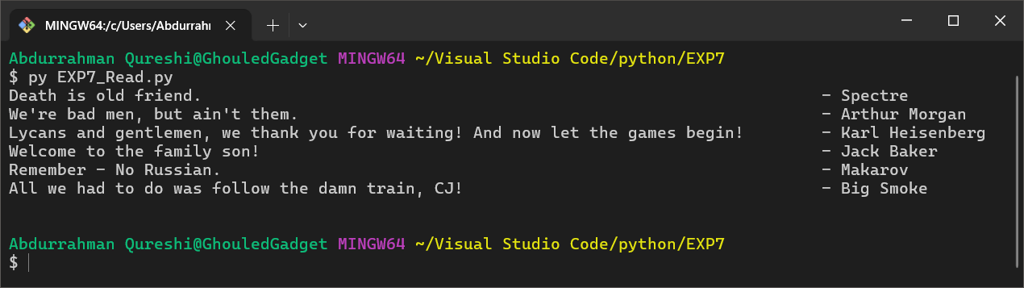

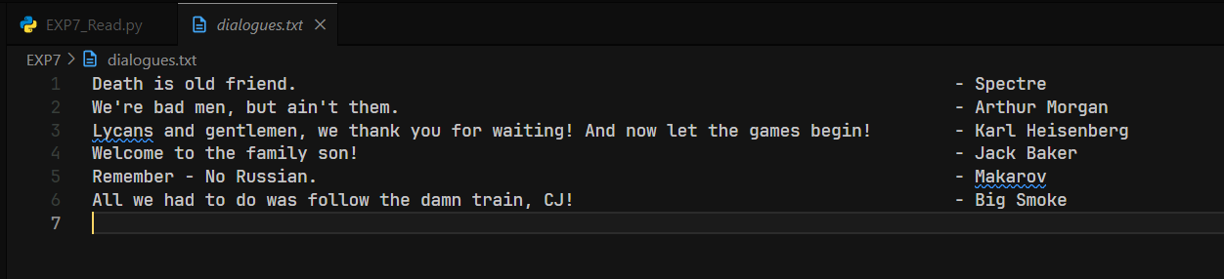

**2) Write a python program to write into the file.**

CODE:

file = open("this_file_is_for_write.txt", 'w')

file.write("Ab ki baar modi sarkaar")

file.close()

file = open("this_file_is_for_write.txt", 'r')

content = file.read()

print(content)

file.close()

OUTPUT:

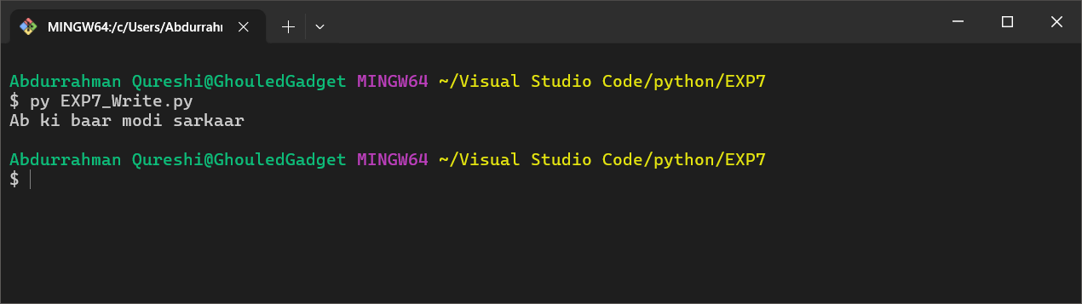

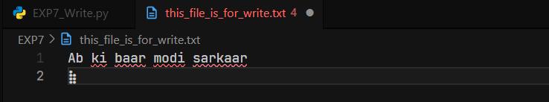

**3) Write a python program to count the occurrences of a given word in a text file.**

CODE:

file = open("dialogues.txt", 'r')

content = file.read()

word_to_search = "the "

times = content.count(word_to_search)

print(content)

print(f"'{word_to_search}' is present in the file {times}")

file.close()

OUTPUT:

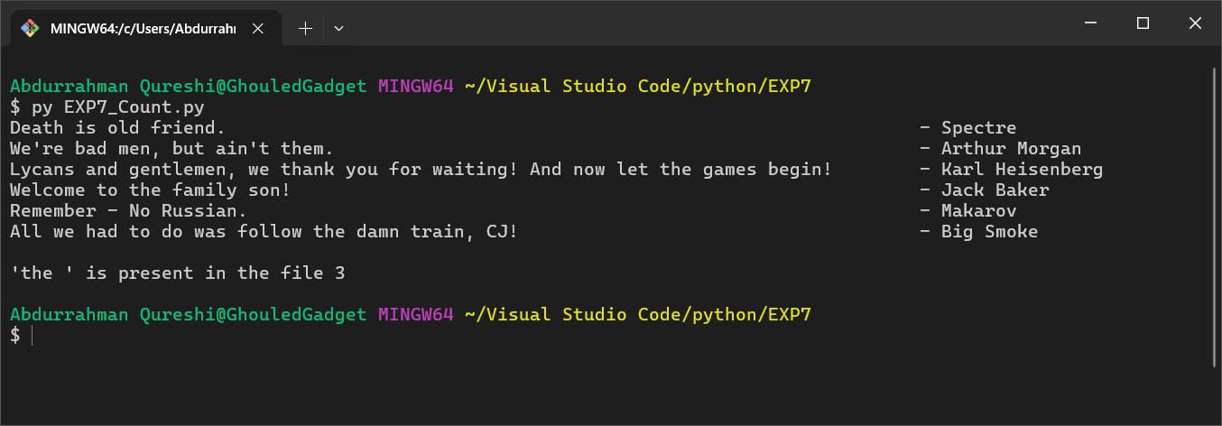

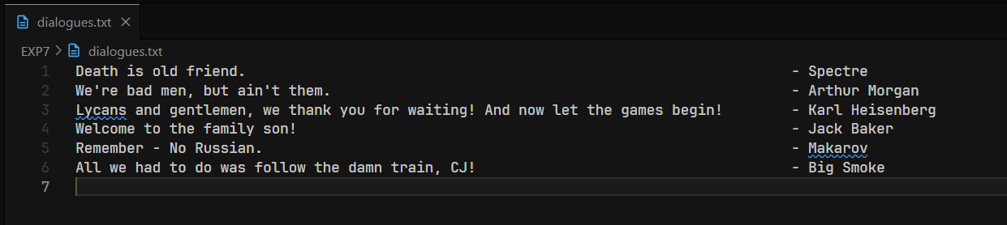

**4) Write a python program to count total no. Of blank spaces in file and replace the blank spaces with a hashtag.**

CODE:

file = open("dialogues.txt", 'r')

content = file.read()

word_to_search = " "

print()

print("-------------------------------------------- Old Content --------------------------------------------")

print()

print(content)

replaced = content.replace(word_to_search , "#")

print("-------------------------------- New Content (' ' replaced with '#') --------------------------------")

print()

print(replaced)

file.close()

file = open("dialogues.txt", 'w')

file.write(replaced)

file.close()

OUTPUT:

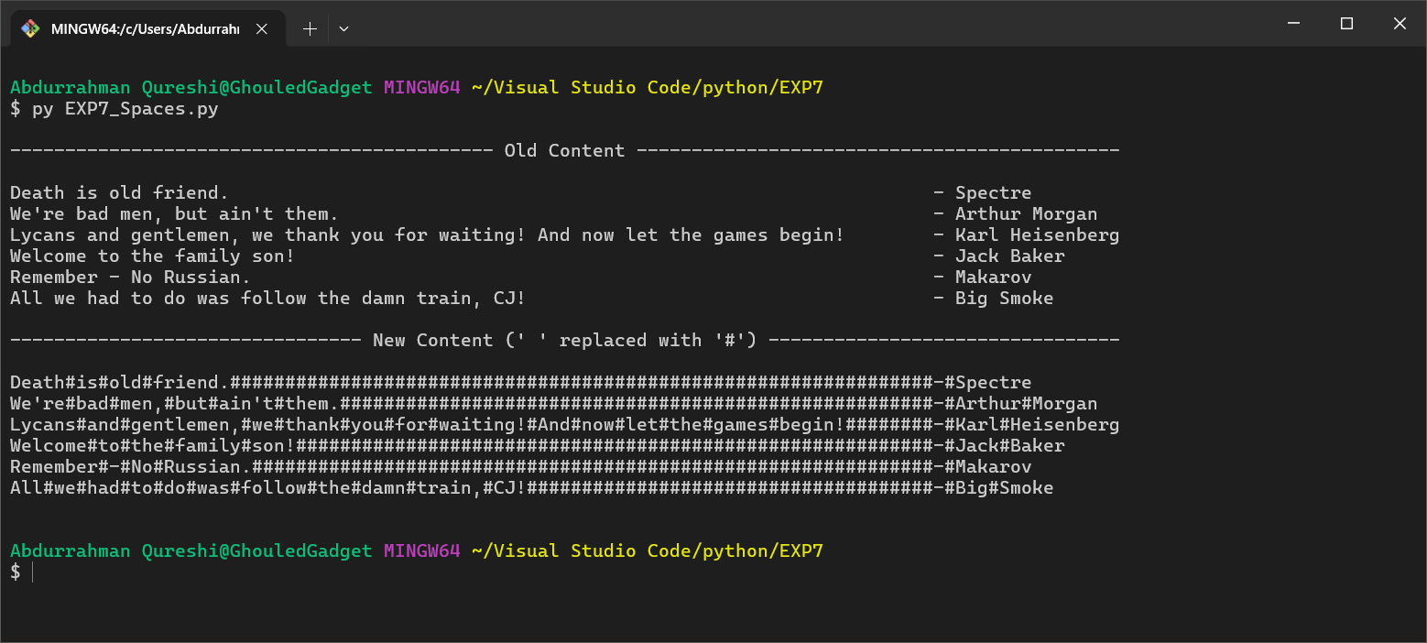

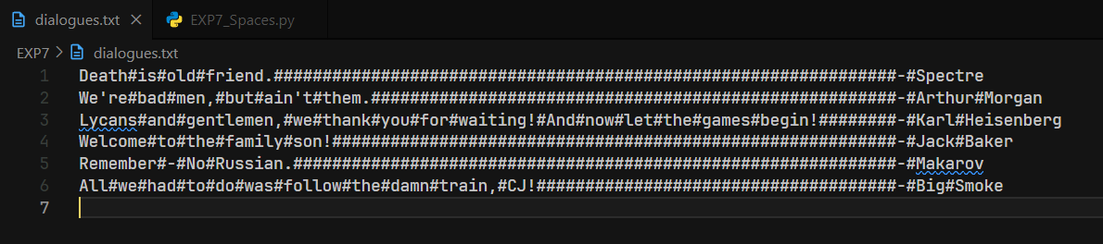

**5) Write a python program to copy content from one file to another file.**

CODE:

file = open("dialogues.txt", 'r')

content = file.read()

print()

print("-------------------------------------------- Old File (dialogues.txt) --------------------------------------------")

print()

print(content)

print("---------------------------------------------- New File (copied.txt) ----------------------------------------------")

print()

print(content)

file.close()

file = open("copied.txt", 'w')

file.write(content)

file.close()

OUTPUT:

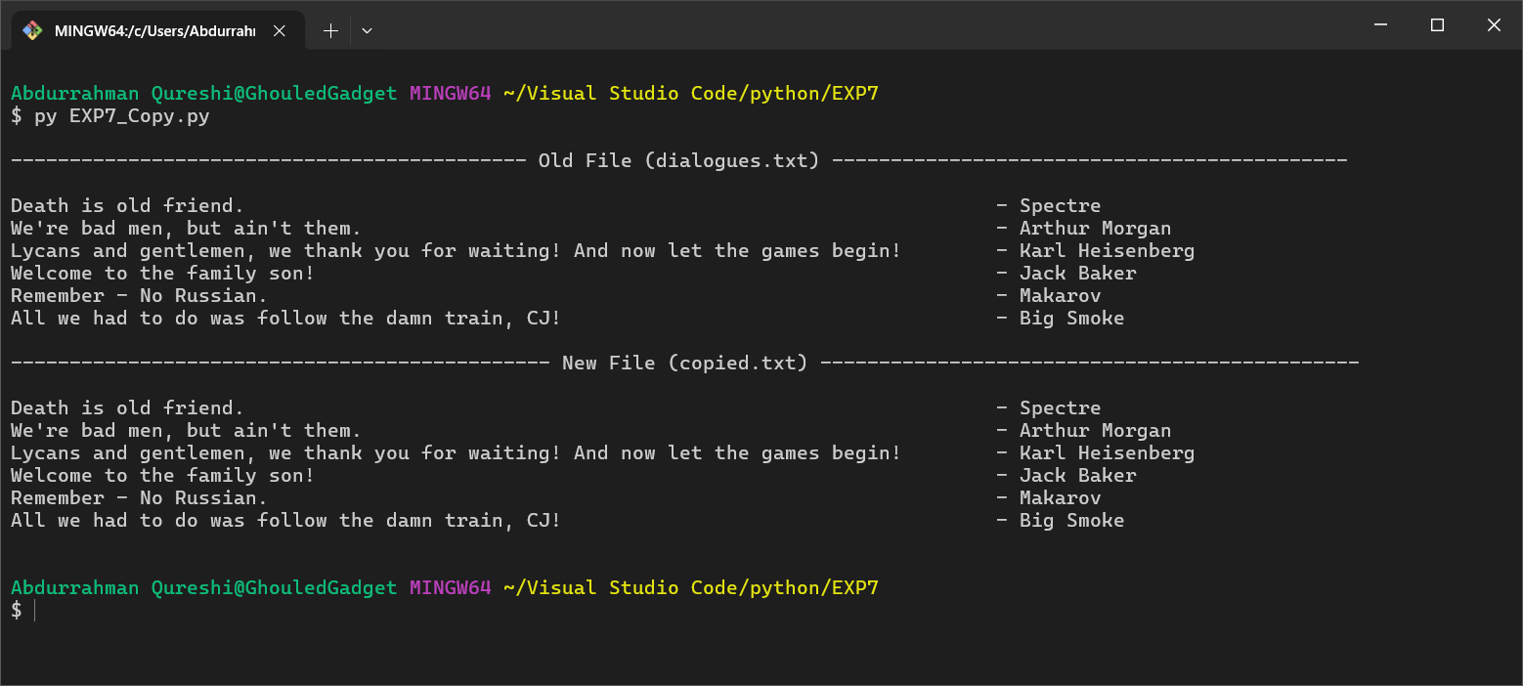

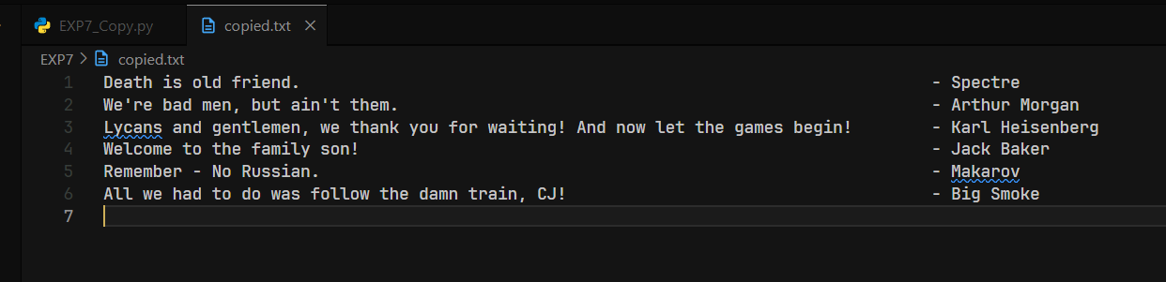

**6) Write a python program to copy an image file.**

CODE:

old_image = open("Lady Dimitrescu.png", "rb")

pixels = old_image.read()

print(pixels)

old_image.close()

new_image = open("Lady D.png", "wb")

new_image.write(pixels)

new_image.close()

OUTPUT:

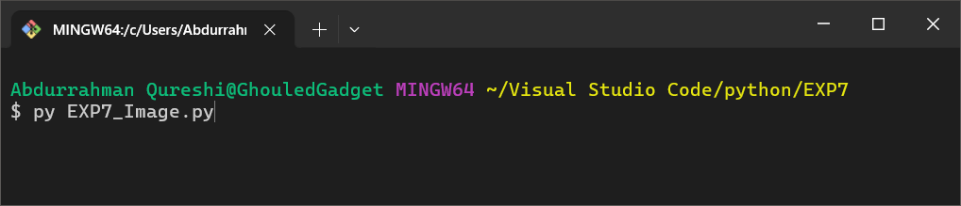

IMAGE IN ‘hexadecimal format’

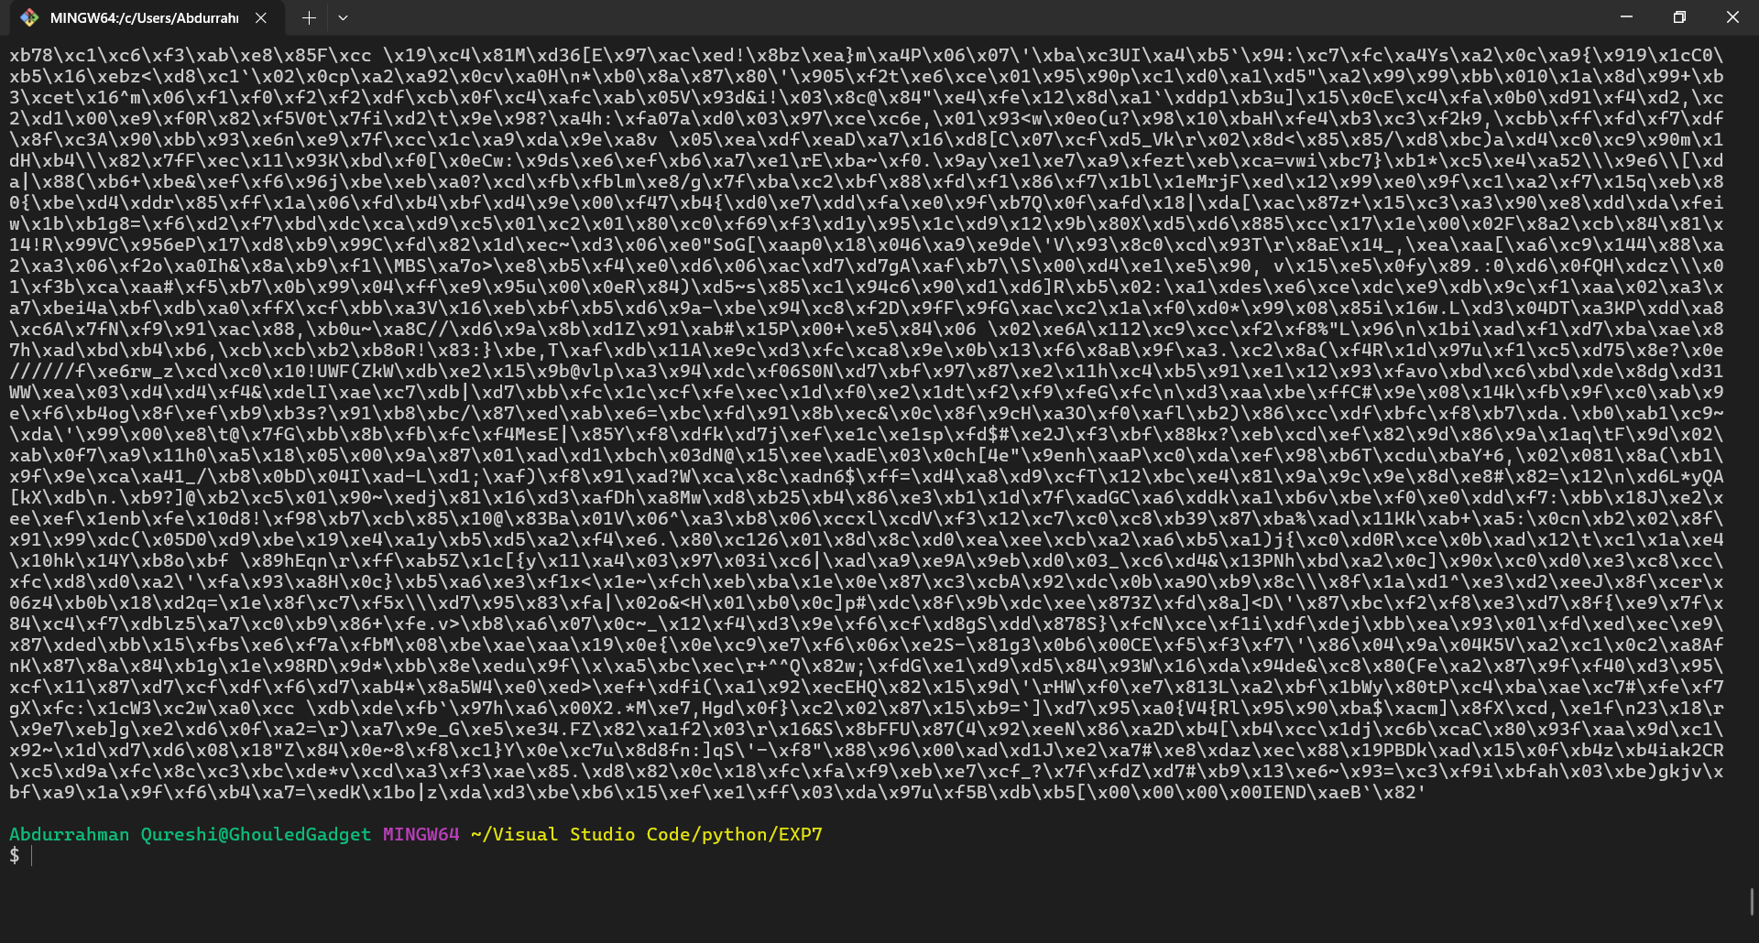

‘Lady D.png’was created and contains the copied the image

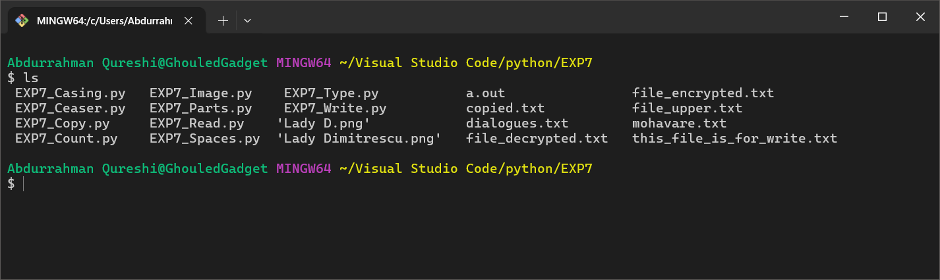

ORGINAL IMAGE ‘Lady Dimitrescu.png’:

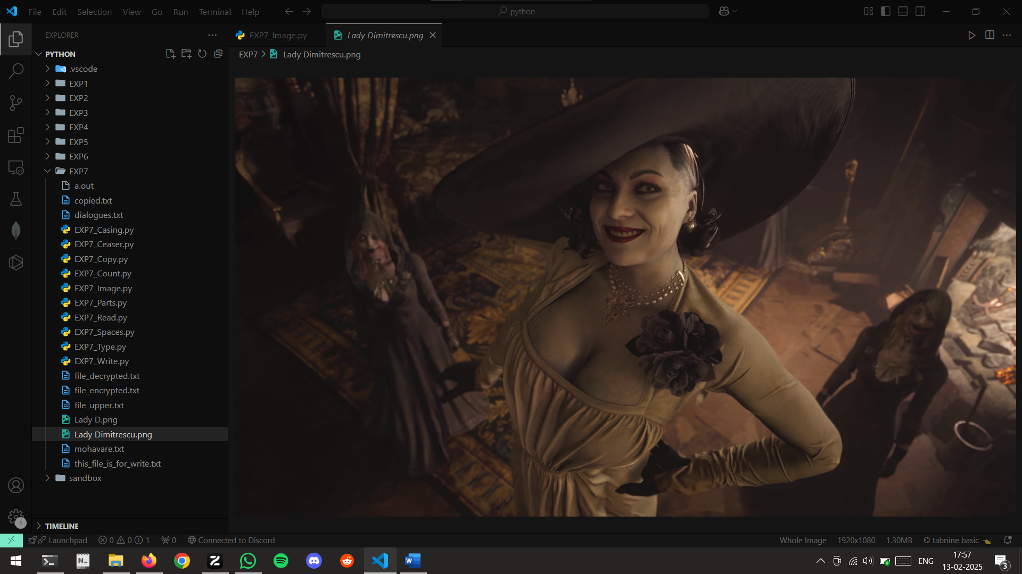

COPIED IMAGE ‘Lady D.png’:

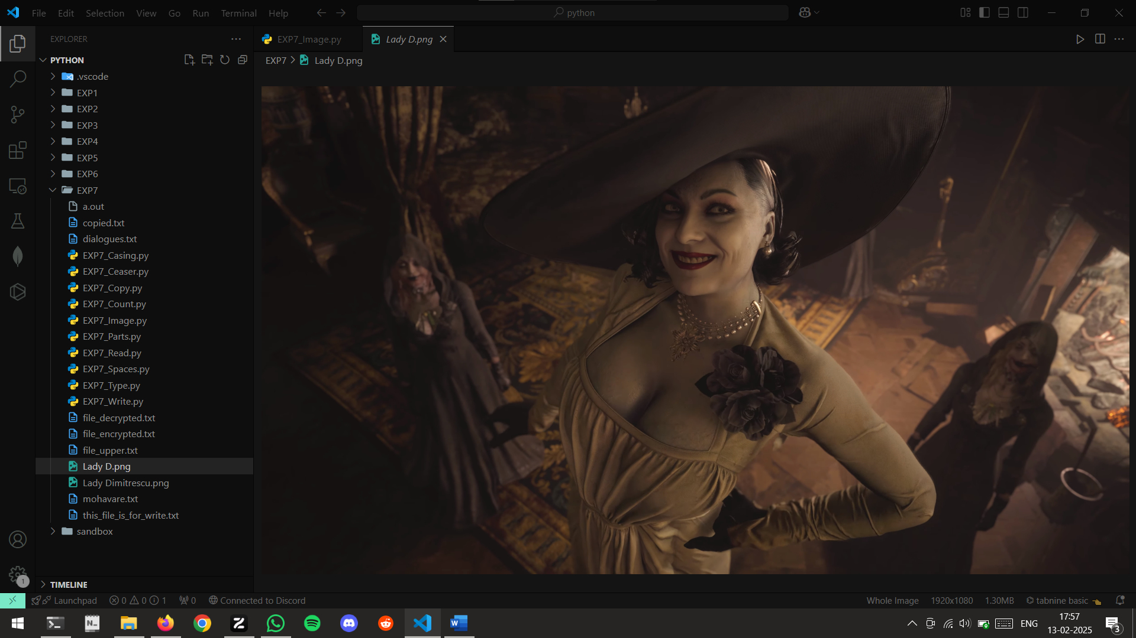

**7) Write a python program to convert lower case characters of one file to upper case characters in another file.**

CODE:

file_lower = open("dialogues.txt", "r")

lower_cased = ""

content = file_lower.read()

for c in content:

    if c.islower():

        lower_cased += c

    if c == " ":

        lower_cased += " "

    if c == "\n":

        lower_cased += "\n"

print(lower_cased)

file_lower.close()

file_upper = open("file_upper.txt", "w")

upper_cased = lower_cased.upper()

file_upper.write(upper_cased)

file_upper.close()

OUTPUT:

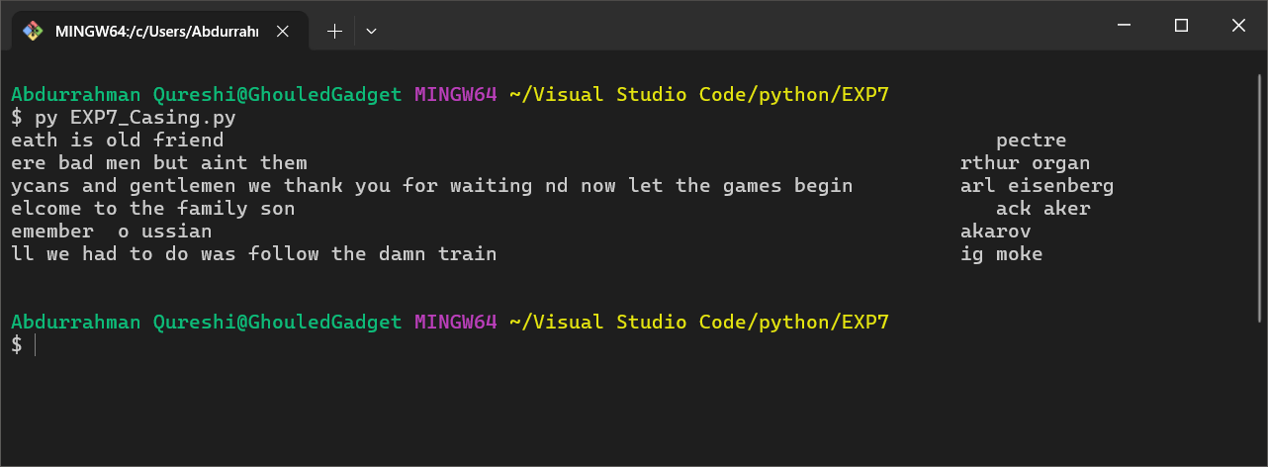

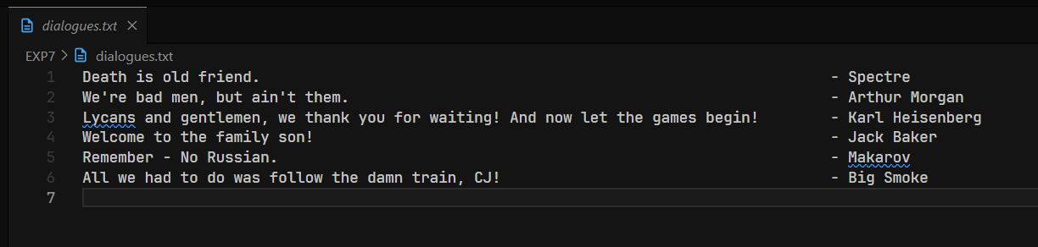

**8) Write a python program to write into the file,read the content of the file and append into the file until the user enters @.**

CODE:

old_file = open("dialogues.txt", "r")

content = old_file.read()

old_file.close()

new_file = open("mohavare.txt", "w")

print()

print("Old Content")

print()

print(content)

char = ""

new_file.write(content)

while char != "@":

    char = input("Enter '@' to exit:")

    new_file.write(char)

new_file.close()

new_fileA = open("mohavare.txt", "r")

content = new_fileA.read()

print()

print("New Content")

print()

print(content)

new_fileA.close()

OUTPUT:

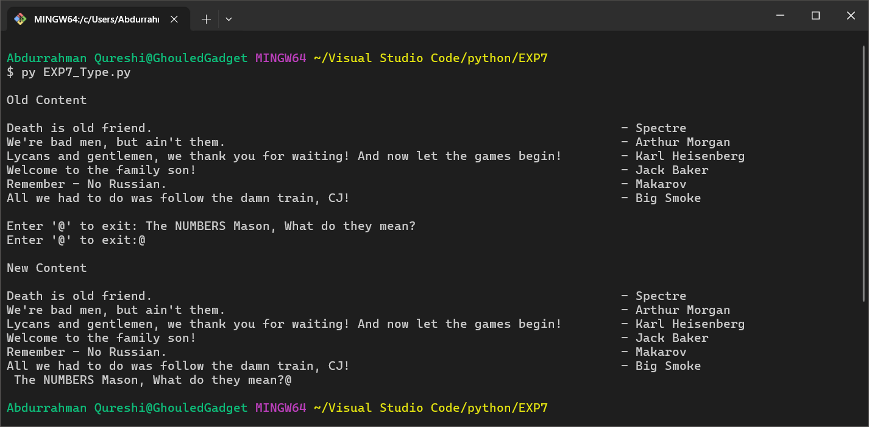

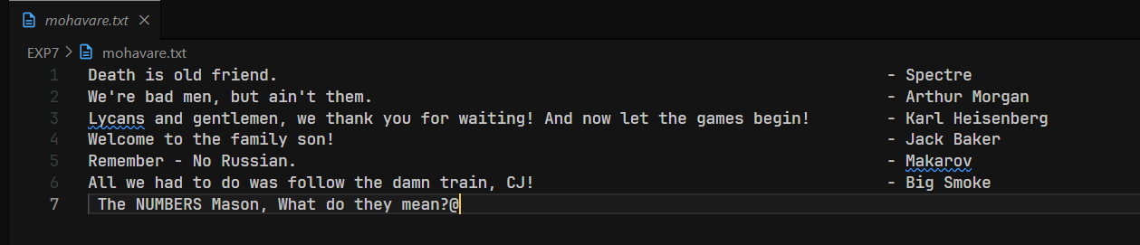

9) Write a python to count no. Of lines , no. Of words , no. Of characters in a text file.

CODE:

file = open("dialogues.txt", "r")

content = file.read()

num_words = 0

num_chars = len(content)

num_lines = 0

for c in content:

    if c == " ":

        num_words += 1

    elif c == "\n":

        num_lines += 1

print()

print(content)

print("Number of words in the file: " , num_words)

print("Number of lines in the file: " , num_lines)

print("Number of characters in the file: " , num_chars)

file.close()

OUTPUT:

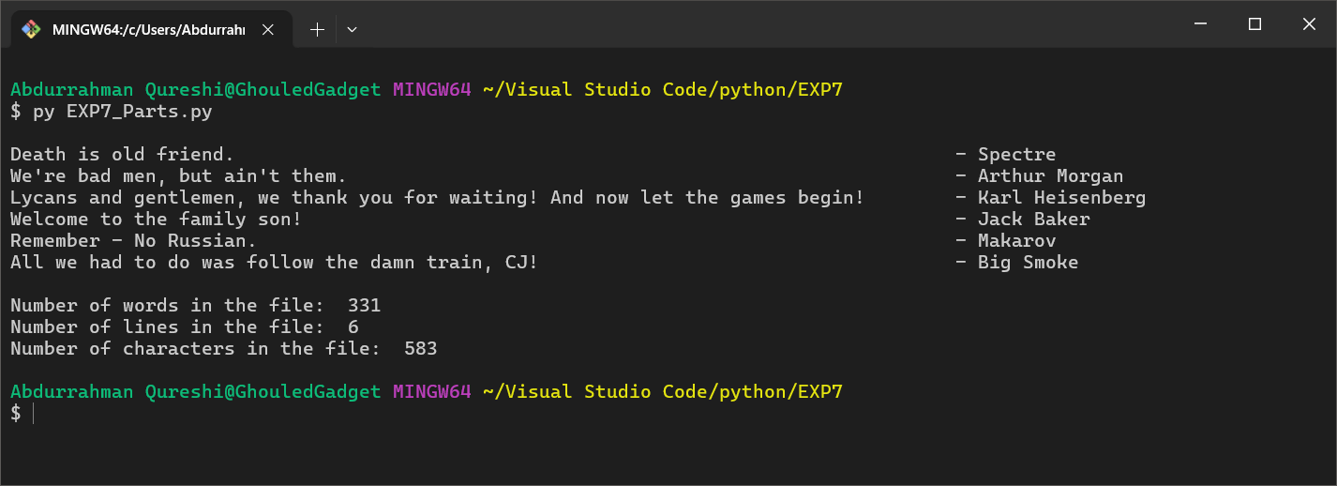

**10) Write a python program to take input from a user encrypted and save it in a file, later read the contents of the file and display the decrypted messages.**

CODE:

def ceaser_cipher(input, key, type):

    characters = ["A", "B", "C", "D", "E", "F", "G", "H", "I", "J", "K","M", "N", "O", "P", "Q", "R", "S", "T", "U", "V", "W", "X", "Y", "Z", "a", "b", "c", "d", "e", "f", "g", "h", "i", "j", "k", "l", "m", "n", "o", "p", "q", "r", "s", "t", "u", "v", "w", "x", "y", "z", "1", "2", "3", "4", "5", "6", "7", "8", "9", "0", "/", "+", " ", "-"]

    base64 = ""

    for char in input:

        if(type == True):

            base64 += characters[(characters.index(char) + key) % len(characters)]

        else:

            base64 += characters[(characters.index(char) - key) % len(characters)]

    return base64

file_encrypted = open("file_encrypted.txt", "w")

content = ""

c = ""

print()

while c != "<>":

    c = input("Enter a string to encrypt or decrypt, type '<>' to exit : ")

    content += c

con = content.replace("<>", " ")

encrypted = ceaser_cipher(con, 17, True)

file_encrypted.write(encrypted)

file_encrypted.write(c)

file_encrypted.close()

print("\nEncrypted content has been saved in 'file_encrypted.txt'")

file_decrypted = open("file_decrypted.txt", "w")

decrypted = ceaser_cipher(encrypted, 17, False)

file_decrypted.write(decrypted)

file_decrypted.close()

print("\nDecrypted content has been saved in 'file_decrypted.txt'")

OUTPUT:

